Setup Docker Network
1 this below command used to list down the networks
docker network ls
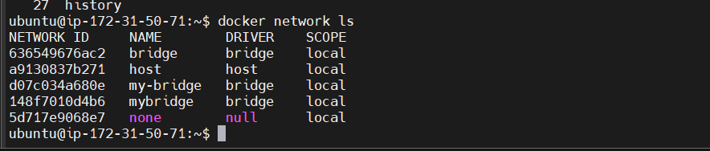

2 create docker bridge network with the name my-bridge
docker network create --driver bridge my-bridge
3 now run nginx on newly created bridge network i.e my-bridge
docker run --name web -d --network my-bridge nginx

4 now to check nginx on which network used below command
docker inspect web
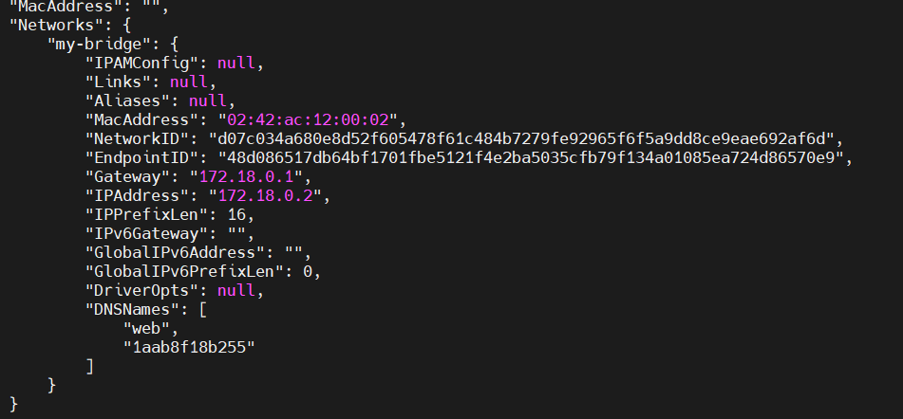
5 you can also inspect network using below command
docker network inspect my-bridge

6 To delete the network use below command
docker network rm my-bridge1

note
if you get below error message then remove the container first

Like this using rm –f command

Create new network with name my-net as bridge network
docker network create my-net

7 Now how to connect nginx container to newly created bridge i.e my-net
docker network connect my-net web
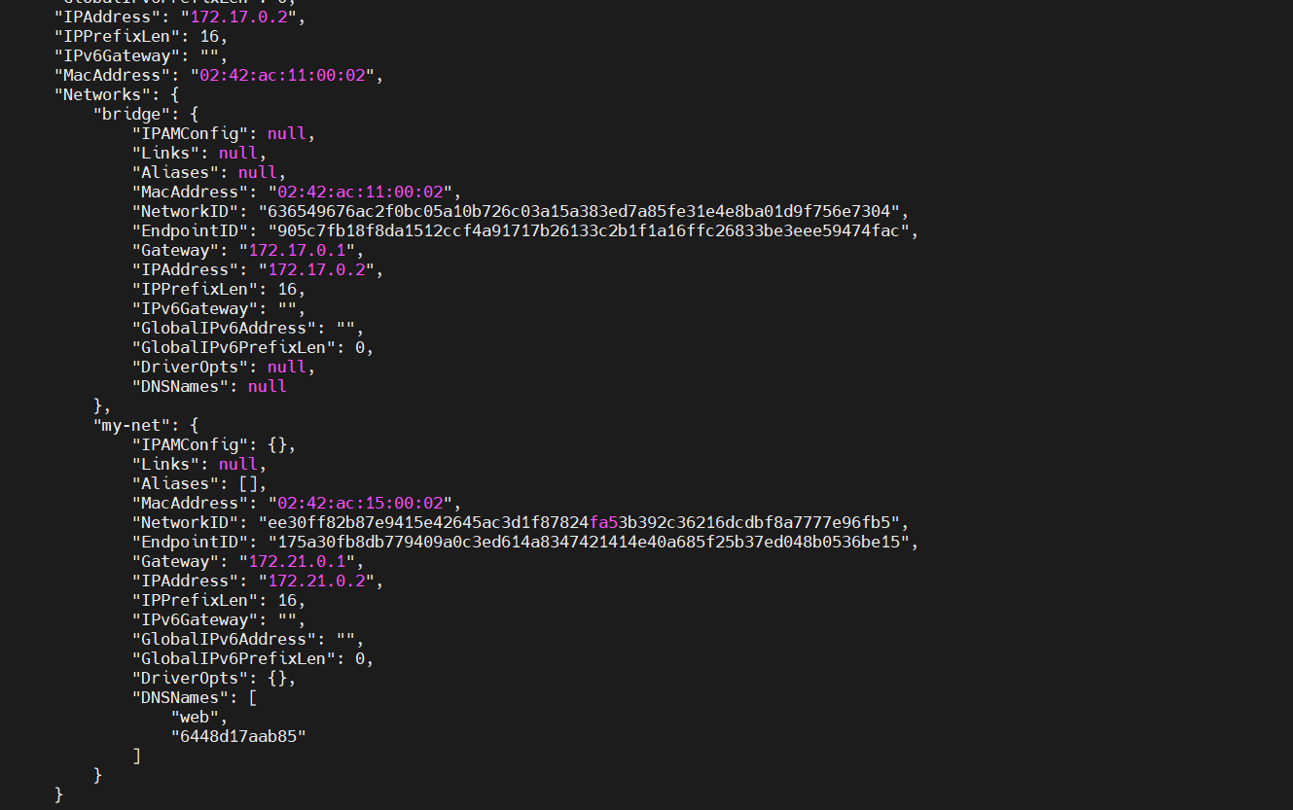

8 you can disconnect to the network using simply disconnect command
docker network disconnect my-net web
removed from network o/p
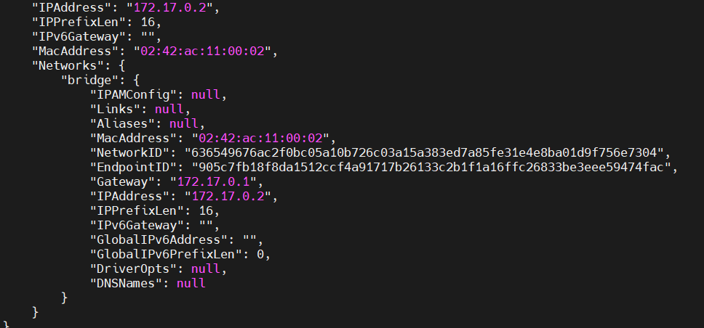
Host Network
9 host nginx in host node using following command

docker run --name web -d --rm --network host nginx

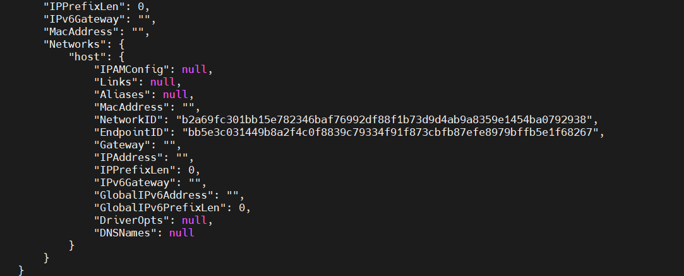

10 to test nginx hosted properly by using following command

curl localhost

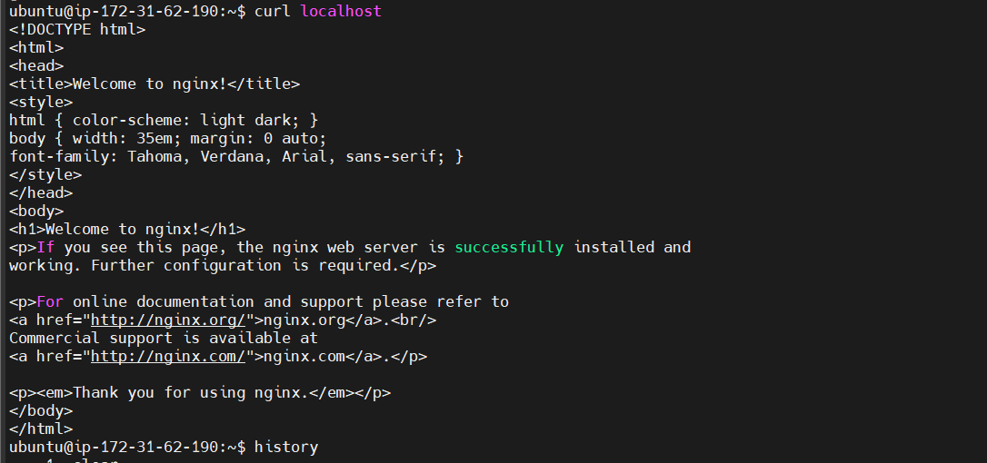

MACVLAN Network Setup

1 create macvlan network using below command

docker network create -d macvlan --subnet=172.16.86.0/24 --gateway=172.16.86.1 -o parent=docker0 macvlan

2 run nginx on top os macvlan network

docker run --name web -d --network macvlan nginx

3 Now inspect weather nginx in configured on macvlan

docker inspect web

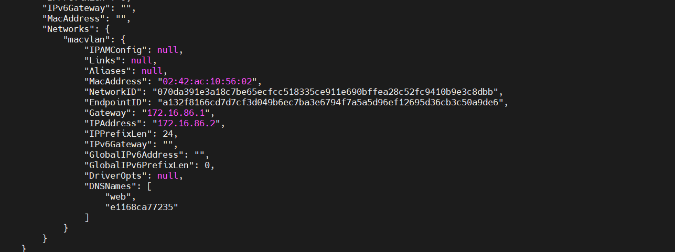

None Network
1 How to setup nignx on none network
docker run --name web1 -d --network=none nginx

2 To inspect use below command
docker inspect web1

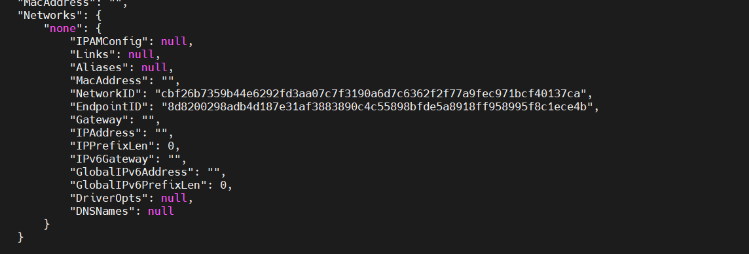

As per observation there is no ip address no gateway, no dns

We can cleanup docker network when no container are running on network inthis case macvlan have running not container so it will get deleted when we use praune command

Note: its same concept like dangling images

docker network prune

o/p
